Schedule component

Life Cycle Plan (LCP)

JEP Online Platform

<Team 15>

Name | First role | Second role
Wei Yan | Developer | Tester
Shreya Nigam | Project Manager | Developer
Wei-ting Cheng | Life Cycle Planner | Developer
Reem Alfayez | Requirement Engineer | Developer
Rebecca Lin | Developer | Tester
Nicholas Pecoraro | IIV&V | Quality Focal Point

<date>

Version History
Date | Author | Version | Changes made | Rationale
09/27/13 | Wei-ting | 1.0 | - Original template | - For VC package
10/16/13 | Wei-ting | 2.0 | - Original template | - For Fc package
10/17/13 | Wei-ting | 2.1 | - Original template | - For Fc package
10/22/13 | Wei-ting | 2.2 | - Add new team member required skill  - Update responsibility of team members | - For Fc package
12/02/13 | Wei-ting | 3.0 | - Update tools | - For DC package
12/04/13 | Wei-ting | 3.1 | - Add 6.1.1-6.1.3 | - For DC package
12/05/13 | Wei-ting | 3.2 | - Edit project plan | - For DC package
12/06/13 | Wei-ting | 3.3 | - Edit project plan | - For DC package
12/08/13 | Wei-ting | 3.4 | - Edit project plan | - For DC package
02/08/14 | Wei-ting | 4.0 | - Modify LCP to 2nd semester  - Modify iteration plan | - Team member leaving  - Role change  - JEP has confirmed their schedule
02/09/14 | Wei-ting | 4.1 | - Modify iteration plan | - For future testing plan
02/09/14 | Wei-ting | 4.2 | - Modify iteration plan | - To fit the time span of the 2nd iteration
02/10/14 | Wei-ting | 4.3 | - Modify iteration plan | - Add making manual
03/26/14 | Wei-ting | 5.0 | - Adding section6.2 | - For CCD
03/30/14 | Wei-ting | 5.1 | - Adding section 6.3 | - For IOC1
04/15/14 | Wei-ting | 5.2 | - Adding feedback | - Get the feedback form JEP
04/30/14 | Wei-ting | 5.3 | - Modify testing result | - For As built package

Table of Contents
Life Cycle Plan (LCP) i
Version History ii
Table of Contents iii
Table of Tables iv
Table of Figures v
1. Introduction 1
2. Milestones and Products 2
3. Responsibilities 3
3.1 Responsibilities by Phase 3
3.2 Skills 5
4. Approach 8
4.1 Monitoring and Control 8
4.2 Methods, Tools and Facilities 8
5. Resources 9
6. Iteration Plan 15
6.1 Plan 15
6.1.1 Capabilities to be implemented 17
6.1.2 Capabilities to be tested 17
6.1.3 Capabilities not to be tested 19
6.2 Iteration Assessment 19
6.2.1 Capabilities Implemented, Tested, and Results 19
6.2.2 Core Capabilities Drive-Through Results 21
6.3 Adherence to Plan 21

Table of Tables
Table 1: Stakeholder's responsibilities 3
Table 2: COCOMOII Scale Driver 9
Table 3: COCOMOII Cost Driver 9
Table 4: COCOMOII Cost Drivers of Module – check_in 10
Table 5: COCOMOII Cost Drivers of Module - Authentication 10
Table 6: COCOMOII Cost Drivers of Module – Student Management 11
Table 7: COCOMOII Cost Drivers of Module –Document Management 12
Table 8: COCOMOII Cost Drivers of Module – site information 12
Table 9: Construction iteration capabilities to be implemented 17
Table 10: Construction iteration capabilities to be tested 17
Table 11: Capabilities not to be tested in iteration 1 19

Table of Figures
Figure 1: COCOMO Estimation Result 14
Figure 2: Iteration Plan 15

    - Introduction

  - Purpose of the LCP
LCP is a backbone document which involves clients and team members. It also contain many critical information like team member’s skill, responsibility in order to make a detail plan in the future, those information will indicate the basic discipline of the whole project. What should people do? When will they work? Who is responsible for what? How will we implement the product. How much can we do.

  - Status of the LCP
The status of the LCP is currently at the VC package version number 1.0. For this very first LCP document, it identifies every stake holder’s responsibility and their skill for future planning.

  - Assumptions
- The project duration is 24 weeks. 12 weeks for 2013 fall and 12 weeks for 2014 spring
- All SCS know their responsibility clearly.

    - Milestones and Products

Exploration phase:
- Duration:2013/Sep/30 – 2013/Oct/5
- Concept: Identify project operational concept, explore and assess NDI.
- Deliverables: VC Package
- Milestone: Valuation Commitment Review
- Strategy: Incremental Commitment Cycle

Valuation phase
- Duration: 2013/Oct/6 – 2013/Oct/16
- Concept: assess the win condition and negotiate with critical stakeholder in order to identify constrain and priority.
- Deliverables: Valuation Commitment Package
- Milestone: Valuation Commitment Review
- Strategy :Incremental Commitment Cycle

Foundation phase
- Duration: 2013/Oct/16 – 2013/Feb/10
- Concept: In this phase, JEP team will follow the foundation plan to complete prototype which satisfy high priority requirement and finish basic construction of component.
- Deliverables: Draft Development Commitment Package
- Development Commitment Review
- Strategy: Concurrent work on prototype and weekly meeting with team and clients. Use Architecture agile method for this project.

Foundation Rebaseline phase
- Duration: 2014/Jan/13 – 2014/Jan/24
- Concept: In this phase, JEP team verifies the schedule of testing, development, and transition plan with JEP.
- Deliverables: Development Commitment Package
- Development Commitment Review
- Strategy: Use Architecture agile method for this project. Release testing version to JEP before the end of two iterations.
    - Responsibilities

Responsibilities by Phase
Table 1: Stakeholder's responsibilities
Name: Wei yan
Role: Developer
Exploration | Team support
Valuation | Identify proper architecture and pattern, Analyze NDI and NCS
Foundations | Assess project architecture, UML model,
Development- Construction Iteration | Developer, Testing
Development- Transition Iteration | Making manual, Support training course

Name: Sherya Nigam
Role: Project Manager,Developer
Exploration | Identify project management approach, record project progress, project planning and management
Valuation | record project progress, project planning and management
Foundations | record project progress, Foundation planning and management, prototyper
Development- Construction Iteration | record project progress, Construction planning and management  Developer,
Development- Transition Iteration | record project progress, plan the transition plan, Making manual, Support training course

Name: Wei-ting Cheng
Role: Life Cycle Planner,Developer
Exploration | Identify stakeholder’s responsibility and skills
Valuation | Estimate effort and schedule, identify life cycle plan approach.
Foundations | Planning Detailed life cycle plan, prototyper
Development- Construction Iteration | Planning Detailed life cycle plan,  Developer,Testing
Development- Transition Iteration | plan the transition plan, Making manual, Training

Name: Reem Alfayez
Role: Requirement Engineer,Developer
Exploration | Capture and Evaluate win conditions, win-win negotiation
Valuation | Analyze feasibility of win conditions
Foundations | Team support, prototyper
Development- Construction Iteration | Team support, Developer, assess iteration product
Development- Transition Iteration | Support training course., Making manual.

Name: Rebbecca Lin
Role: Feasibility Analyst,Developer
Exploration | Analyze Business Case, Analyze NDI and NCS
Valuation | Assess requirements, Assess NDI and NCI
Foundations | Assess Feasibility, prototype, Assess protyper
Development- Construction Iteration | Assess Feasibility, Developer, Testing, Assess iteration product
Development- Transition Iteration | Support training course, Making manual.

Name: Ricardo Solano(leave)
Role: Operation Concept Engineer
Exploration | Analyze Current System, Assess Operational Concept, Explore Alternatives,
Valuation | Identify Objectives Constraints and Priorities, Identify Organization and Operation
Foundations | Prototype, Assess operation concept
Development- Construction Iteration
Development- Transition Iteration

Name: Nicholas Pecoraro
Role: IIV&V
Exploration | Team support
Valuation | Verify and validate work produc, manage work quality.
Foundations | Verify and validate work product
Development- Construction Iteration | Verify and validate work product
Development- Transition Iteration | Verify and validate work product

Name: JEP staff
Role: Client
Exploration | Analysis current System, Analysis business workflow, Provide win conditions, Provide necessary resource
Valuation | Assess prototype and components
Foundations | Access prototype and documents.
Development- Construction Iteration | Access testing version of product, provide and organize volunteer for testing.
Development- Transition Iteration | Client evaluation.

Skills
Team members | Role | Skills
Wei Yan | System Architect/  Developer | Current skill: My SQL, MS SQL Server, Microsoft terminal services client (MSTSC)  Java, C++, C, Racket, Python, SQL  HTML, MXML, XML, Flex, Javascript, Actionscript, XSLT  Architecture analysis for several projects, database  Required skill:  Knowledge of architecture and pattern, UML model
Sherya Nigam | Project Manager/  Developer | Current skill:  C, C++, Java, Socket programming, SQL  HTML, XML  wireless remote monitoring of devices  Required skill:  Project management skill  Team member coordination  Client interaction
Wei-ting Cheng | Life Cycle Planner/  Developer | Current skill:  C, C++, Java  HTML,php css,SQL  Image processing  android application development  Required skill:  Human resource planning skill  Life cycle planning skill
Reem Alfayez | Requirement Engineer/  Developer | Current skill:  Java,C#HTML,CSS,  PHP,ASP.NET,  ,JavaScript,jQuery AJAX,VB.NET,JSF,JS.  Required skill:  Client negotiation  Requirement assessment
Rebecca Lin | Feasibility Analyst/  Developer | Current skill:  C, C++, Java  HTML, JSP  Android app development  Required skill:  Requirement assessment  Risk analyzation
Ricardo Solano(leave) | Operational Concept Engineer | Current skill:  Java, C++  HTML, Javascript  Automotive Control System Design  PCB Design  Required skill:  Operational concept analyzation  Business workflow
Nicholas Pecoraro | IIV&V | Current skill:  Java Enterprise framework  HTML, Perl, PHP, Javascript, CSS.  XML, KML, SQL, MySQL, SQLITE  Spring, Android SDK, Python(a little) , C++, Maven, SVN, shell scripting, web services.  Required skill:  Production validation
Future team member | Operational Concept Engineer | Required skill:  PHP, HTML5, Javascript  SQL  Having experience of connecting website to a secured database.
    - Approach

Monitoring and Control
Use Progress Report to monitor everyone’s work progress and monitor the whole project and the risk. Buglizza focus on the current working progress project manager and IIV&V control the progress by assign team members works and monitor if the work is done.

Closed Loop Feedback Control
Use what’s app to send urgent information by instant message or some discussion which don’t need much time so that everyone can have latest information. For some reasons, those instant message are easily ignored, we send important message through mail to every teammates, sometime include client, to make sure everyone is updated. Weekly meeting is hold in order to discussing the problem we are facing and to plan next move.

Reviews
Use peer review by sending document through email to everyone before upload to team website. Outside the team, use winbook to let client review our decisions.
After this phase, it start to dealing with code more, we will use SVN to share our code and that every know where has been modified.

Methods, Tools and Facilities
Tools | Usage | Provider
Balsamiq | Provide tools to draw prototype outlook | Open source
COINMOII | Estimate the effort of the project | USC
Google API | Provide library of google map and google calendar | Open source
Winbook | Help to negotiate requirements with clients | USC
Visual paradigm | UML modeling | USC
SVN | Code sharing and review | Nick

Resources
- Estimated CSCI577a Effort : 7 team members at 12 hrs/week for 12 weeks
- Estimated CSCI577b Effort : 7 team members at 12 hrs/week for 12 weeks
- Total estimated effort : 13.26PM
- Budget information: 0
- Project duration : 24 weeks
- Component modules in your development project:
- Check_in
- Authentication
- Student management
- Document management
- Site information
- Schedule component

- Programming language used: PHP,css,HTML5,SQL

Table 2: COCOMOII Scale Driver
No. | Module Name | Brief Description | SLOC
1 | Check_in | Allow students to check in. | 1000
2 | Authentication | User will get their permission to access the JEP online platform. This also include session handling, different user will see different view. | 400
3 | Student management | JEP staff can search all student’s information and program assistance can only see their students’ information. | 600
4 | Document management | Program assistance can upload the document and students can view the document. | 400
5 | Site information | Students can see the site information and site direction which is related to them. | 800
6 | Schedule component | Student can view their schedule. | 800

Table 3: COCOMOII Cost Driver
Scale Driver | Value | Rationale
PREC | Low | We are not familiar with website for mobile phone and has no experience in develop check_in function and log_in.
FLEX | High | The project is much flexible, clients accept every suggestion which can meet their primary goal.
RESL | Nominal | we have access the feasibility of requirement but don’t have back up plane
TEAM | High | Every teammates are very cooperate. However, sometimes someone can’t come to meeting and may have to delay the progress due to their other work.
PMAT | Low | Since we are still students learning knowledge of software engineering, we don’t have a mature process.

The following is the result from COCOMOII estimation based on Scale Drivers and Cost Drivers discussed above.

Table 4: COCOMOII Cost Drivers of Module – check_in
Cost Driver | Value | Rationale
RELY | Nominal | It is the main function of the project. However, it would not have financial loss and professor can use other way to note down the attendance.
DATA | Low | The student’s check may only send and capture a very little data.
DOCU | Nominal | Because the development process follows ICSM, the document for life-cycle needs is normal.
CPLX | High | It need geo location chek_in, and is much complex.
RUSE | Low | It is not intended to be reused for the future project.
TIME | Nominal | It don’t have much time constrain.
STOR | Nominal | It don’t have much storage constraint.
PVOL | Low | The major change will be longer than 1 year
ACAP | Nominal | Our analysis and design ability is not like profession one.
PCAP | Nominal | Much of us don’t have working experience but we still have solid ability to programming.
PCON | Nominal | Only 2 team members will leave this team after 577a
APEX | Low | None of us have experience developing such system
LTEX | Nominal | More than half of us have those programming language experience.
PLEX | Nominal | We have experience on website and all of us have SQL experience.
TOOL | Low | We don’t have any experience on cold fusion but it highly mature platform.
SITE | High | Most of us are highly collocated.
SCED | Nominal | The schedule is fixed for 12 weeks in Fall semester and 12 weeks in Spring semester.

Table 5: COCOMOII Cost Drivers of Module - Authentication
Cost Driver | Value | Rationale
RELY | High | If the JEP staff cannot access the system they can not do their job and if the authentication is wrong, other student may see what they were not able to see.
DATA | Low | The data it captured is not large since it only capture the information of the log_in account.
DOCU | Nominal | Because the development process follows ICSM, the document for life-cycle needs is normal.
CPLX | Nominal | The website have only to handle the authentication
RUSE | Low | It is not intended to be reused for the future project.
TIME | Nominal | It don’t have much time constrain.
STOR | Nominal | It don’t have much storage constraint.
PVOL | Low | The major change will be longer than 1 year
ACAP | Nominal | Our analysis and design ability is not like profession one.
PCAP | Nominal | Much of us don’t have working experience but we still have solid ability to programming.
PCON | Nominal | Only 2 team members will leave this team after 577a
APEX | Low | None of us have experience developing such system
LTEX | Nominal | More than half of us have those programming language experience.
PLEX | Nominal | We have experience on website and all of us have SQL experience.
TOOL | Low | We don’t have any experience on cold fusion but it highly mature platform.
SITE | High | Most of us are highly collocated.
SCED | Nominal | The schedule is fixed for 12 weeks in Fall semester and 12 weeks in Spring semester.

Table 6: COCOMOII Cost Drivers of Module – Student Management
Cost Driver | Value | Rationale
RELY | Nominal | It is the basic function for JEP staff and PA. if this function is down, then they have to retrieve the information form the old system.
DATA | High | The JEP can see all the student’s information.
DOCU | Nominal | Because the development process follows ICSM, the document for life-cycle needs is normal.
CPLX | High | What we have to implement is to show the student’s information base on the users authentication
RUSE | Low | It is not intended to be reused for the future project.
TIME | Nominal | There are not much time constrain.
STOR | Nominal | There are not much storage constraint.
PVOL | Low | The major change will be longer than 1 year
ACAP | Nominal | Our analysis and design ability is not like profession one.
PCAP | Nominal | Much of us don’t have working experience but we still have solid ability to programming.
PCON | Nominal | Only 2 team members will leave this team after 577a
APEX | Low | None of us have experience developing such system
LTEX | Nominal | More than half of us have those programming language experience.
PLEX | Nominal | We have experience on website and all of us have SQL experience.
TOOL | Low | We don’t have any experience on cold fusion but it highly mature platform.
SITE | High | Most of us are highly collocated.
SCED | Nominal | The schedule is fixed for 12 weeks in Fall semester and 12 weeks in Spring semester.

Table 7: COCOMOII Cost Drivers of Module –Document Management
Cost Driver | Value | Rationale
RELY | Low | If this function is down PA can still send the document to the site or to the student.
DATA | Low | It capture very less data.
DOCU | Nominal | Because the development process follows ICSM, the document for life-cycle needs is normal.
CPLX | Low | it only upload the profile and the browser can support the download and view.
RUSE | Low | It is not intended to be reused for the future project.
TIME | Nominal | It don’t have much time constrain.
STOR | Nominal | It don’t have much storage constraint.
PVOL | Low | The major change will be longer than 1 year
ACAP | Nominal | Our analysis and design ability is not like profession one.
PCAP | Nominal | Much of us don’t have working experience but we still have solid ability to programming.
PCON | Nominal | Only 2 team members will leave this team after 577a
APEX | Low | None of us have experience developing such system
LTEX | Nominal | More than half of us have those programming language experience.
PLEX | Nominal | We have experience on website and all of us have SQL experience.
TOOL | Low | We don’t have any experience on cold fusion but it highly mature platform.
SITE | High | Most of us are highly collocated.
SCED | Nominal | The schedule is fixed for 12 weeks in Fall semester and 12 weeks in Spring semester.

Table 8: COCOMOII Cost Drivers of Module – site information
Cost Driver | Value | Rationale
RELY | Low | If it is dysfunction, JEP staff can still use old system and student can use online map application.
DATA | Low | It retrieve the site address.
DOCU | Nominal | Because the development process follows ICSM, the document for life-cycle needs is normal.
CPLX | Low | It only retrieves the site address and we can use google API to implement the direction.
RUSE | Low | It is not intended to be reused for the future project.
TIME | Nominal | It don’t have much time constrain.
STOR | Nominal | It don’t have much storage constraint.
PVOL | Low | The major change will be longer than 1 year
ACAP | Nominal | Our analysis and design ability is not like profession one.
PCAP | Nominal | Much of us don’t have working experience but we still have solid ability to programming.
PCON | Nominal | Only 2 team members will leave this team after 577a
APEX | Low | None of us have experience developing such system
LTEX | Nominal | More than half of us have those programming language experience.
PLEX | Nominal | We have experience on website and all of us have SQL experience.
TOOL | Low | We don’t have any experience on cold fusion but it highly mature platform.
SITE | High | Most of us are highly collocated.
SCED | Nominal | The schedule is fixed for 12 weeks in Fall semester and 12 weeks in Spring semester.

Table 9: COCOMOII Cost Drivers of Module – Schedule
Cost Driver | Value | Rationale
RELY | Nominal | Although the students may not see their schedule to plan their schedule, it is easy recoverable.
DATA | Nominal | It capture every site information of student have choose.
DOCU | Nominal | Because the development process follows ICSM, the document for life-cycle needs is normal.
CPLX | Low | We will just show all the event of the site order by date.
RUSE | Low | It is not intended to be reused for the future project.
TIME | Nominal | It don’t have much time constrain.
STOR | Nominal | It don’t have much storage constraint.
PVOL | Low | The major change will be longer than 1 year
ACAP | Nominal | Our analysis and design ability is not like profession one.
PCAP | Nominal | Much of us don’t have working experience but we still have solid ability to programming.
PCON | Nominal | Only 2 team members will leave this team after 577a
APEX | Low | None of us have experience developing such system
LTEX | Nominal | More than half of us have those programming language experience.
PLEX | Nominal | We have experience on website and all of us have SQL experience.
TOOL | Low | We don’t have any experience on cold fusion but it highly mature platform.
SITE | High | Most of us are highly collocated.
SCED | Nominal | The schedule is fixed for 12 weeks in Fall semester and 12 weeks in Spring semester.

The following is the result from COCOMOII estimation based on Scale Drivers and Cost Drivers discussed above.
Figure 1: COCOMO Estimation Result
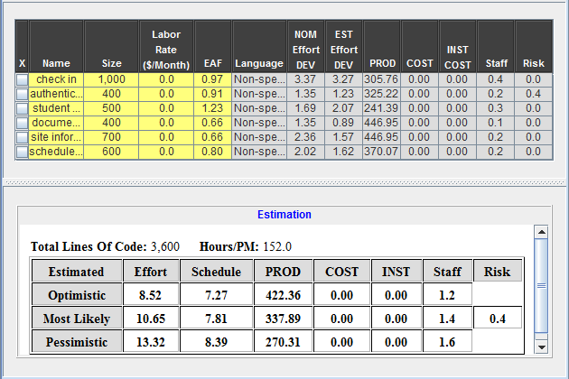

The average engineer work per month is 152 which is set by the COINCOMO. We work 12 hours per weeks and have 24 weeks so we will have 152/(12*24)=0.527, we have 7 developers so10.65*0.527 = 5.61 13.32*0.527=7.01. It is more than the most likely case but less than pessimistic case.

6. Iteration Plan

6.1 Plan
Figure 2: Iteration Plan

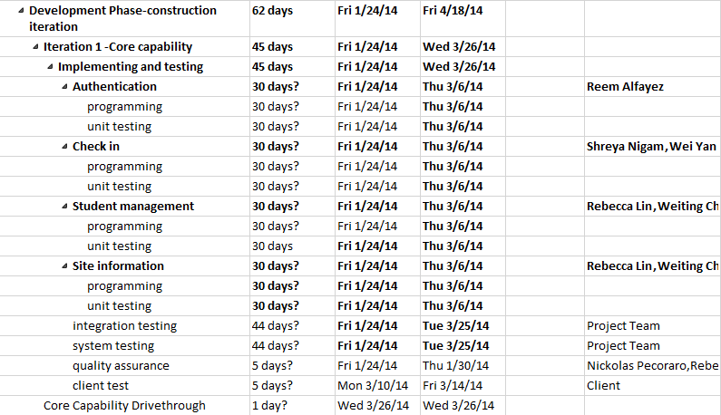
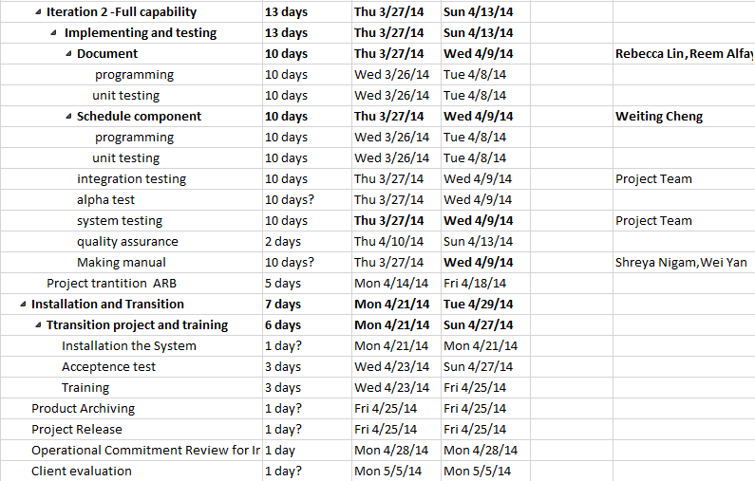

6.1.1 Capabilities to be implemented
Table 9: Construction iteration capabilities to be implemented
ID | Capability | Description | Priority | Iteration
1 | Check_in | Allow students to check in. | 1 | 1
2 | Authentication | User will get their permission to access the JEP online platform. This also include session handling, different user will see different view. | 2 | 1
3 | Student management | JEP staff can search all student’s information and program assistance can only see their students’ information. | 3 | 1
4 | Document management | Program assistance can upload the document and students can view the document. | 4 | 2
5 | Site information | Students can see the site information and site direction which is related to them. | 5 | 2
6 | Schedule component | Student can view their schedule. | 6 | 2

6.1.2 Capabilities to be tested
Table 10: Construction iteration capabilities to be tested
ID | Capability | Description | Priority | Iteration
TC-01 | Check_in | As a JEP volunteer, I can check-in my geo location on through the website either from my phone or pc, to confirm my attendance at a school or volunteer site. | 1 | 1
TC-09 | Check_in | As a JEP staff(PA,Admin), I can set the message that students will get when they checked_in by setting the message start date, end date, and content. | 4 | 1
TC-10 | Check_in | As a JEP staff(PA,Admin), I can edit the message that students will get when they checked_in by setting the message start date, end date, and content. | 4 | 1
TC-01 | Check_in | As a JEP volunteer, I get a message when I check in | 4 | 1
TC-11 | Authentication | As a user, I can view the proper website view based on my role after I logged in | 2 | 1
TC-12 | Authentication | As a user, I can log out. | 2 | 1
TC-11 | Authentication | As a user I can log in. | 2 | 1
TC-14 | Authentication | As an admin, I can add users(admins, and PA) to the system by adding their USC ID, and selecting their role(Admin, PA) | 2 | 1
TC-15 | Authentication | As an admin, I can edit users'(admins, and PA) roles in the system. | 2 | 1
TC-16 | Authentication | As an admin, I can delete users'(admins, and PA) roles in the system. | 2 | 1
TC-13 | Student management | As JEP Admin, I can search student view and their infromation | 3 | 1
TC-07 | Student management | As JEP PA, I can browse my student information | 3 | 1
TC-06 | Student management | As a program assistant, I can export my students successful check-ins information which includes(date,time,and site) | 3 | 1
TC-08 | Document management | As a program assistant , I can upload JEP important pdf documents | 4 | 2
TC-04 | Document management | As a JEP volunteer, I can view a list of all JEP documents. | 4 | 2
 | Student management | As a JEP staff(PA,Admin), I can set the message that students will get when they checked_in by setting the message start date, end date, and content. | 3 | 1
TC-10 | Student management | As a JEP staff(PA,Admin), I can edit the message that students will get when they checked_in by setting the message start date, end date, and content. | 4 | 1
TC-01 | Check_in | As a JEP volunteer, I get a message when I check in | 4 | 1
TC-18 | Site information | As an admin, I can edit site information Name,Dress Code,No School,Early Dismissal,Image,Office Location,Office Location,Address,Principal Name,Coordinator's info(First Name,Last Name ,e-mail,Office Location) | 5 | 1
TC-17 | Site information | As an admin, I can add site information including Name,Dress Code,No School,Early Dismissal,Image,Office Location,Office Location,Address,Principal Name,Coordinator's info(First Name,Last Name ,e-mail,Office Location) | 5 | 1
TC-19 | Site information | As an admin, I can delete a site. | 5 | 1
TC-02 | Site information | As a JEP volunteer, I can log in and find my site information including location, description, and site times that I am supposed to go there. | 5 | 1
TC-03 | Site information | As a JEP volunteer, I can see maps to and from community sites and USC. | 5 | 1
TC-01 | Check_in | As a JEP volunteer, I can check-in my geo location on through the website either from my phone or pc, to confirm my attendance at a school or volunteer site. | 1 | 2
TC-05 | Schedule component | As a JEP volunteer, I can log in and find my site information including location, description, and site times that I am supposed to go there. | 6 | 2

6.1.3 Capabilities not to be tested
Table 11: Capabilities not to be tested in iteration 1

6.2 Iteration Assessment

6.2.1 Capabilities Implemented, Tested, and Results
Here list the core capabilities implemented in the first iteration and their test result. The rest component will be implemented in the second iteration and then have fully test.
Table 12: Capabilities implemented, tested, and results
ID | Capability | Test Case | PC version | Mobile version | Rational
1 | Receive Announcement Upon Checkin | TC-01 | Yes | Yes
2 | View Volunteer’s Assigned Site Info | TC-02 | Yes | Yes
3 | Get Directions to Site | TC-03 | Yes | Yes
4 | View JEP Documents | TC-04 | Yes | yes
5 | View Schedule Information | TC-05 | Yes | Yes
6 | Export Checkin Information | TC-06 | Yes | NA | Mobile version don't have this function.
7 | Browse Volunteer Information | TC-07 | yes | NA | Mobile version don't have this function.
8 | Manage JEP Documents | TC-08 | Yes | NA | Mobile version don't have this function.
9 | Set Announcement for Volunteers | TC-09 | Yes | Yes
10 | Edit Announcement for Volunteers | TC-10 | yes | Yes
11 | Login | TC-11 | Yes | Yes
12 | Logout | TC-12 | Yes | Yes
13 | Search Volunteer Information | TC-13 | Yes | Yes
14 | Add User | TC-14 | Yes | NA | Mobile version don't have this function.
15 | Edit User | TC-15 | Yes | NA | Mobile version don't have this function.
16 | Delete User | TC-16 | Yes | NA | Mobile version don't have this function.
17 | Add Site | TC-17 | Yes | NA | Mobile version don't have this function.
18 | Edit Site | TC-18 | Yes | NA | Mobile version don't have this function.
19 | Delete Site | TC-19 | Yes | NA | Mobile version don't have this function.

6.2.2 Core Capabilities Drive-Through Results
- Basically JEP have very positive feedback on the check in function. It has more function than they think. For example, it can change the transportation method the route. Also, it has detail information on the map.
- However, some of them think the user manual is helpful but some don’t. it might happened according to the role of the client. People who are satisfied by the manual is closer to technical staff.
- Most of the change JEP required is the text of the system to make them more understand the information or the function of the bottom. For example, JEP ask to change the add permission to add user. Also they want to change time format to more readable format.
- Another change is the export function which only work in certain environment.

6.3 Adherence to Plan
Basically, the first iteration have a few day delay to its original due day. However, it benefit team15 to have more time in the second iteration because we move one component to first iteration. Also, the delayed component is not actually core capability.

It is in the budget since the whole project actually doesn’t purchase anything.

There are some part we fail to this project in the first iteration.
First, the underestimation of effort of the UI and mobile website. It takes too much time and disturb the original plan. In the future, we should have more detail design decision in the planning phase to avoid this situation
Second, we didn’t have a well-organized version control system so that we waste approximate 2 days per person to make the project updated to the latest version. This happened especially when multiple people working in the same component in the same time. Sometimes one will overwrite another’s code and make a confusion of each other. Setting a rule that one have to inform every team mates that one have mode some change of the component and allow another one to update the code immediately. Also, every team mates have responsibility to let their code updated to the latest version.
Third, we didn’t receive the feedback form JEP after the week they test the website. In the CCD, JEP has asked for some change of the requirement. However, team 15 should receive the feed a week before CCD because JEP have a week to test the JEP online platform.

